

Materials TodaydVolume 50 � November 2021 RESEARCH

HIGHLIGHTED PAPER

Unexpectedly low barrier of ferroelectric switching in HfO2 via topological domain walls

Duk-Hyun Choe, Sunghyun Kim, Taehwan Moon, Sanghyun Jo, Hagyoul Bae, Seung-Geol Nam, Yun Seong Lee, Jinseong Heo⇑

Inorganic Material Lab., Samsung Advanced Institute of Technology (SAIT), Suwon 16678, Republic of Korea

Fluorite-structure ferroelectrics — in particular the orthorhombic phase of HfO2 — are of paramount interest to academia and industry because they show unprecedented scalability down to 1-nm-thick size and are compatible with Si electronics. However, their polarization switching is believed to be limited by the intrinsically high energy barrier of ferroelectric domain wall (DW) motions. Here, by unveiling a new topological class of DWs, we establish an atomic-scale mechanism of polarization switching in orthorhombic HfO2 that exhibits unexpectedly low energy barriers of DW motion (up to 35-fold lower than given by previous conjectures). These findings demonstrate that the nucleation-and-growth-based mechanism is feasible, challenging the commonly held view that the rapid growth of the oppositely polarized domain is impossible. Building on this insight, we describe a strategy to substantially reduce the coercive fields in HfO2-based ferroelectric devices. Our work is a crucial step towards understanding the polarization switching of HfO2, which could provide a means to solve the key problems associated with operation speed and endurance.

Keywords: Ferroelectrics; Polarization switching; Domain walls; Topological domain walls; HfO2-based electronics

Introduction   
The discovery of ferroelectricity in HfO2-based materials [1] has inspired a renewed interest in fluorite-structure oxides for next-generation electronic devices [2–4]. The orthorhombic phase of HfO2 (o-HfO2; Pca21) [5–7] can exhibit robust ferroelectricity down to its ultimate limits in both lateral and vertical dimen-sions [8,9]. Moreover, mature deposition techniques for prepar-

|  |  |  |  |  |  |  |  |
| --- | --- | --- | --- | --- | --- | --- | --- |
| ing | HfO2 | compatible | with | Si | technology | offer | exciting |

opportunities for realizing ‘negative capacitance’ [10–12] in Si-based devices, which could overcome the thermodynamic limits on their power consumption. Despite these compelling advan-tages over traditional perovskite-structure ferroelectrics [13], two major challenges exist for memory and logic applications:

Abbreviations: DW, domain wall; QC, quasi-chirality.⇑ Corresponding author.

E-mail address: Heo, J. ([jinseong.heo@samsung.com](mailto:jin—seong.heo@sam—sung.—com))

the low endurance caused by the characteristically high coercive fields [2] and the issue of sluggish polarization switching [14,15], which are assumed to be intrinsic to o-HfO2 [9].

Polarization switching driven by an electric field is among the most fundamental and intriguing properties of ferroelectrics. Understanding its mechanism is not only of fundamental inter-est but also central for their use in future electronic devices, such

|  |  |  |  |  |  |
| --- | --- | --- | --- | --- | --- |
| as | ferroelectric | field-effect-transistors | (FETs) | [2,4,16] | and |

negative-capacitance FETs [10,12]. In perovskite-structure ferro-electrics, for example, the switching generally occurs through the nucleation and growth mechanism [17–19], namely, the for-mation of reverse domain followed by the rapid expansion of the domain walls (DWs). However, the microscopic mechanism of polarization switching in fluorite-structure ferroelectrics remains uncertain [20]. A direct experimental identification of switching dynamics in high-quality o-HfO2 samples is desirable [21], but

|  |  |
| --- | --- |
| 8 | 1369-7021/� 2021 Elsevier Ltd. All rights reserved. <https://doi.org/10.1016/j.mattod.2021.07.022> |

|  |  |  |
| --- | --- | --- |
| Materials TodaydVolume 50 � November 2021 | RESEARCH |  |
|  | even lower than those of traditional perovskite ferroelectrics | RESEARCH: Short Communication |
| still challenging because most synthesized HfO2-based ferroelec- |
| tric films are polycrystalline [22] and single-crystalline o-HfO2 is | [31]. This not only sets a substantially higher upper bound for |
| generally difficult to synthesize [3] owing to its relative instabil- | the intrinsic switching speed in o-HfO2, but also demonstrates |
| ity compared with the monoclinic phase (P21/c) [6]. More impor- | a fundamentally different switching mechanism compared with |
| tantly, without clear theoretical guidance for the microscopic | the previously accepted mechanism that prohibits domain |
| details of the DWs and their dynamics, experimental verification | growth after nucleation [9,23,24,32]. Our findings can explain |
| is largely based on trial and error [20]. | most recent observations of ultrafast ferroelectric switching |
| Unfortunately, existing theories of polarization switching in | [25,27,33] and the evidence of nucleation and growth behavior |
| o-HfO2 impose considerable limitations on their functionality. | in ferroelectric HfO2 [28]. Moreover, we propose a field effect |
| In particular, the widely-accepted model from first-principles cal- | transistor with a gate stack composed of fluorite oxides that exhi- |
| culations suggests that the expansion of oppositely polarized | bits lower coercive fields. This work may resolve the current key |
| domains is practically impossible owing to the insurmountable | issues for using ferroelectric HfO2 in future electronics and |
| energy barrier for the DW motion [9,23,24]. This implies an | unlocks new possibilities of polar skyrmion electronics [34,35] |
| inherently slow polarization switching in o-HfO2, which can be | based on topological DWs in HfO2. |
| a critical drawback for logic and memory applications. Although |

sluggish ferroelectric switching observed in early experiments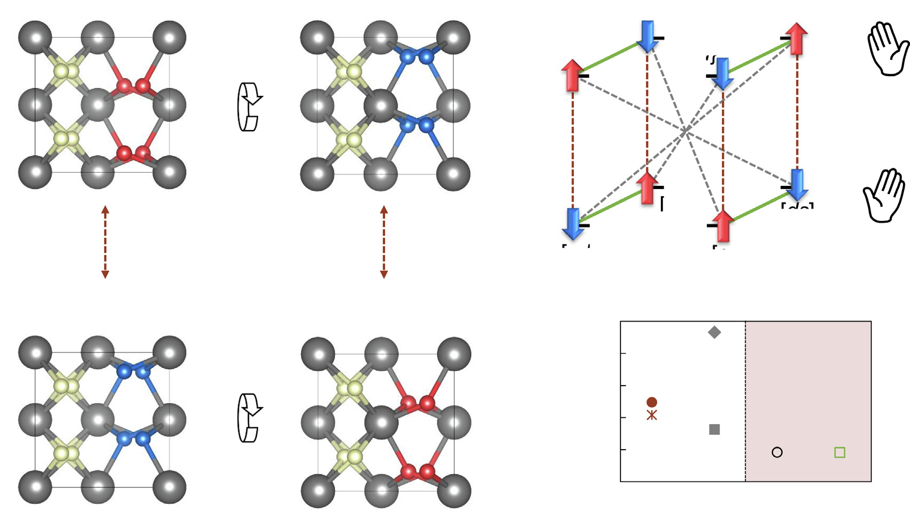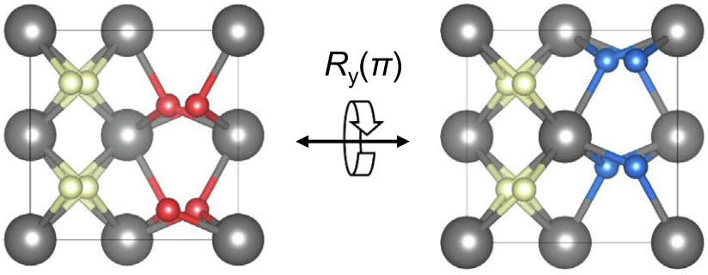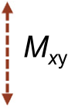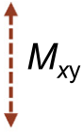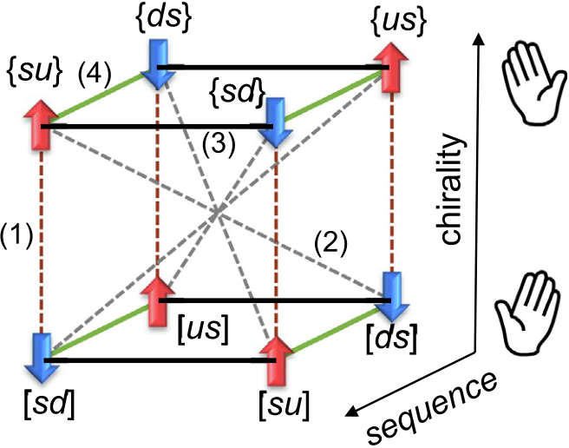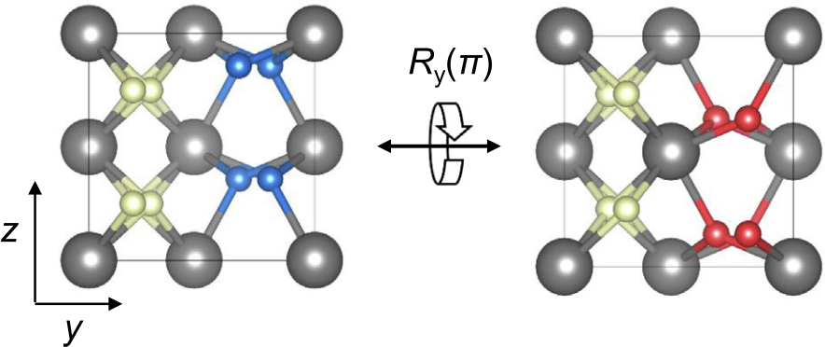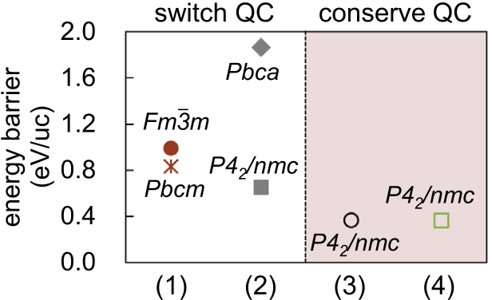

[14,15] partly support this theory, recent experiments provide Results

important clues about rapid DW growth in HfO2-based ferro-electrics; including ultrafast (sub-ns scale) switching perfor-mance [25–27], DW motion limited switching behavior [28], and hysteresis-free negative capacitance effect [11], raising fun-damental questions about the underlying mechanism. In multi-scale simulations [29,30], on the other hand, it is often taken for granted that the DWs in HfO2-based ferroelectrics are mobile, contrary to the prevalent first-principles insight. Therefore, this study aims to resolve these ambiguities and provide an accurate

|  |  |  |  |  |  |
| --- | --- | --- | --- | --- | --- |
| understanding | of | atomic-scale | ferroelectric | switching | in |

fluorite-structure ferroelectrics.

Here we use first-principles calculations to show that the energy barriers for the polarization switching in o-HfO2 can be

Quasi-chiral nature of orthorhombic HfO2   
We begin by describing the quasi-chiral nature in the crystal structure of o-HfO2. Fig. 1a and 1b show the atomic structures of o-HfO2 in up and down polarized states, respectively. Its unit cell consists of two types of alternating segments [9,36]: the non-polar spacer and the polar layer, which we refer to as s and u or d (up or down), respectively. Applying the Euclidean transforma-tions (rotation, translation, and/or reflection) in the unit cell gives rise to 8 different representations of the o-HfO2 unit cell [24]. Four examples are shown in Fig. 1a–d, and the full dimen-sional space including their geometrical relationships is depicted as a cube in Fig. 1e. To better understand the structural properties of o-HfO2, we here introduce the concept of quasi-chirality. We

|  |  |  |  |  |  |  |
| --- | --- | --- | --- | --- | --- | --- |
| (a) |  |  | (c) |  |  | (e) |
| (b) |  | (d) | (f) |

|  |  |  |
| --- | --- | --- |
|  |  |  |

|  |
| --- |
| FIGURE 1 |

Quasi-chiral nature of the structure of o-HfO2. (a–d) Four representative atomic structures of the unit cell of o-HfO2. The gray balls denote Hf atoms, while

ivory, red, and blue balls denote O atoms in the spacer, up polar, and down polar layers, respectively. (e) A cube depicting the relationships between the 8

distinct unit cell representations. (f) The calculated energy barriers for four different homogeneous polarization switching pathways in o-HfO2. The space

group symmetries of the intermediate phase are indicated as a guidance [see also Fig. S1 in the Supplementary Material].

9

|  |  |
| --- | --- |
| RESEARCH | Materials TodaydVolume 50 � November 2021 |
| find that o-HfO2 structure becomes chiral when the system size is finite, as in thin films, along the polar direction (z-axis). We refer to this conditional chirality as quasi-chirality (QC). In our nota-tion, the atomic structures in Fig. 1a–d are respectively expressed as {su}, [sd], {sd}, and [su], where {���} and [���] denote the right- and left-handed QC of the o-HfO2 structure, respectively. | Pbca intermediate phase [Fig. S1 in Supplementary Material], which has a high energy barrier of 1.86 eV/uc. The high energy barriers of pathways (1) and (2) are associated with the change in the QC from right(left) to left(right)-handedness during the switching process [24]. In contrast, pathways (3) and (4) do not involve such a QC reversal, resulting in a smaller energy barrier. |

It is also interesting to note that the pathway via the Pbcm inter-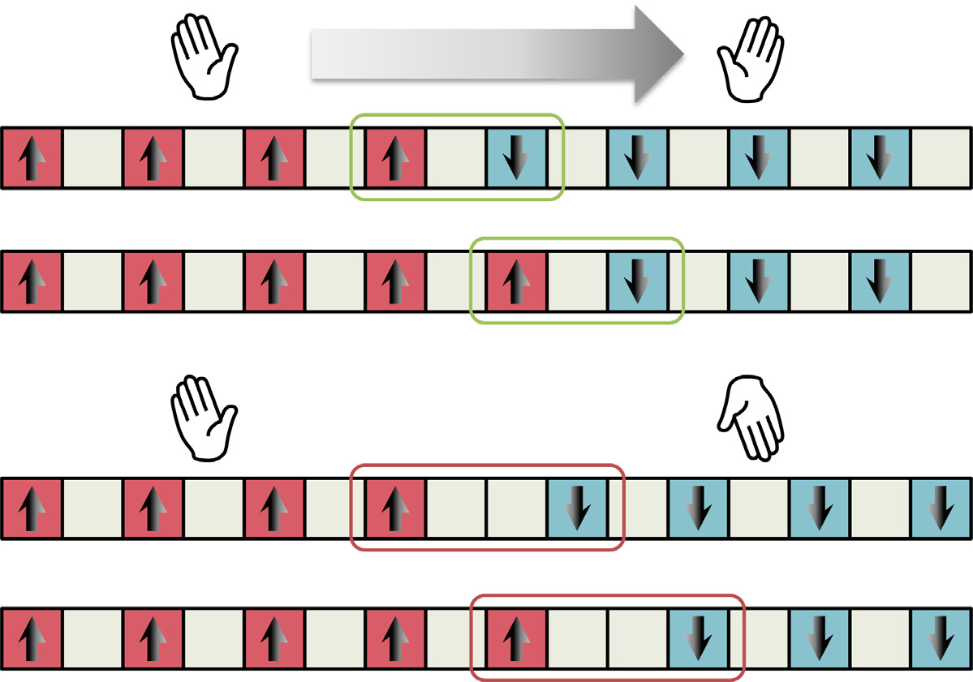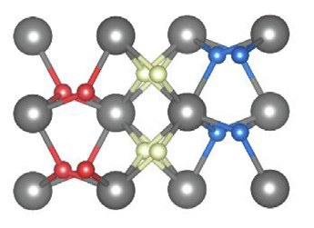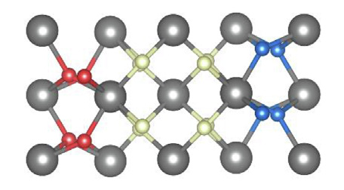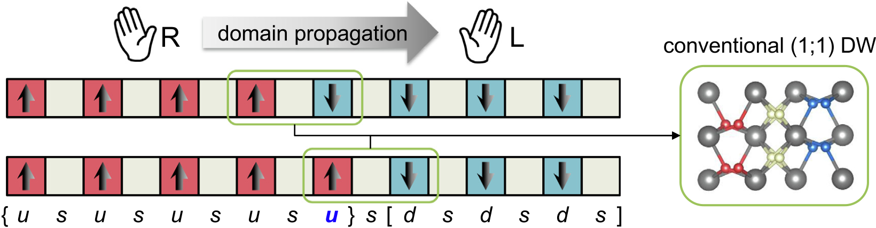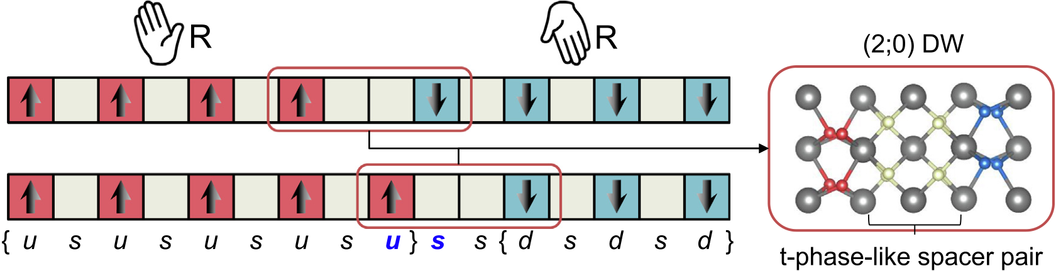

|  |  |
| --- | --- |
| Homogeneous polarization switching  A simple way to investigate polarization switching in ferro-electrics is to consider the homogenous switching pathways, in which the entire crystal is switching coherently from up to down (or down to up) states. Based on the relationships between the o-HfO2 unit cell (uc) representations (Fig. 1e), we categorize the homogeneous switching pathways into 4 different types, for instance, starting from {su}: (1) ? [sd], (2) ? [ds] (3) ? {sd}, and (4) ? {ds} (see Fig. S1). Fig. 1f shows the energy barriers cal- | mediate phase [37,38], which can be considered type (1), is dis-tinctly different from the others, because O atoms move in the opposite direction compared with those of other pathways, so that the polarization orientations can be interpreted in the oppo-site manner [see Supplementary Discussion].  New class of DWs  Homogenous polarization switching, however, is unlikely in practice because ferroelectric switching usually proceeds via |

culated from first principles (see Methods) during the switching process for the 4 types of pathways. The calculated barriers are in good agreement with the theoretical values in the literature [6,9,23,24,37], except the type (2) pathway via an unreported

(a)

(b)

the DW motion [19]. At first sight, the most plausible DW between oppositely polarized domains in o-HfO2 would be the one presented in previous studies [9,15,23,24], which has a single spacer s between the two domains with different QC,

|  |
| --- |
| (c) (d) (e) |

|  |
| --- |
| FIGURE 2 |

Schematic illustration of the DW motions from nu = N to nu = N + 1 involving (a) single-segment switching in (1;1) DW and (b) two-segment switching in (2;0) DWs, where nu is the number of up polar layers. The segments that participate in the switching process are denoted as bold blue letters below the schematic illustrations. The DW regions of (1;1) and (2;0) DWs are respectively highlighted by green and red boxes. The two spacers ss in the (2;0) DW are geometrically

very similar to the tetragonal phase of HfO2 (Fig. S2b). (c) The relative total energy (DU) along the minimum energy path (MEP) for the two types of DW motions. (d) Strain dependent DU for the DW motion of (2;0) DWs. An intermediate state resembling the Pbcn phase (Fig. S2a) exists in the pathway between nu = N and nu = N + 1. (e) The relative energy for the intermediate state (DUintermediate) and the energy barrier for the DW motion (Umo) as a function of tensile strain.

10

|  |  |  |
| --- | --- | --- |
| Materials TodaydVolume 50 � November 2021 | RESEARCH |  |
|  | DW motion | |  | | --- | | RESEARCH: Short Communication | |
| i.e., {���u}s[d���] or [���u]s{d���} (Fig. 2a). Its low DW energy has led to the widespread belief that it is responsible for the DW |
| The current view of DW motion during ferroelectric switching in |
| motion during the polarization reversal. Here we generalize this | o-HfO2 relies on (1;1) DW [9,23,24], where a single down polar |
| DW geometry and introduce a group of DWs in o-HfO2, by | layer d is switched to an up polar layer u while fixing the neigh- |
| varying the number of spacers (n) between the polar segments | boring spacers (Fig. 2a), i.e., {���u}s[dsd���] ? {���usu}s[d���] (bold letters indicate the segments participating in a DW propagation |
| at the boundaries of the two domains (Fig. S2). A representative |
| case with n = 2 is shown in Fig. 2b. We note that the DWs | process). A disadvantage of this mechanism, however, is that it |
| with n = even and n = odd are topologically distinct from each |
| is accompanied by a local QC reversal owing to the structural |
| other. When n = even, the sequence of the spacer and polar |
| constraints imposed by the fixed neighboring spacers, resulting |
| layers in one of the domains is reversed compared to the oppo- |
| in a high energy barrier for DW motion, Umo, which is 1.36 eV. |
| site domain, while the sequences for both domains are the | We observed a remarkably low Umo for (2;0) DW (Fig. 2b). As |
| same for n = odd. As a result, the transition between different | shown in Fig. 2c, the calculated Umo is merely 73 meV |
| topological classes of DWs requires a global structural transfor- | (2.73 meV/Å2), which can be further reduced to 36 meV |
| mation throughout the whole domain. On the contrary, the | (1.36 meV/Å2) by the application of a tensile strain as small as |
| transition between the DWs that belong to the same class only |
| 0.3% (Fig. 2d and 2e). The latter is about 35-fold lower than |
| requires a local structural transformation near the DW. We also |
| Umo for unstrained (1;1) DW and is comparable or even smaller |
| introduce the QC index (vc) as an additional descriptor of the |  |  |
| than those calculated for a well-known perovskite ferroelectric, |

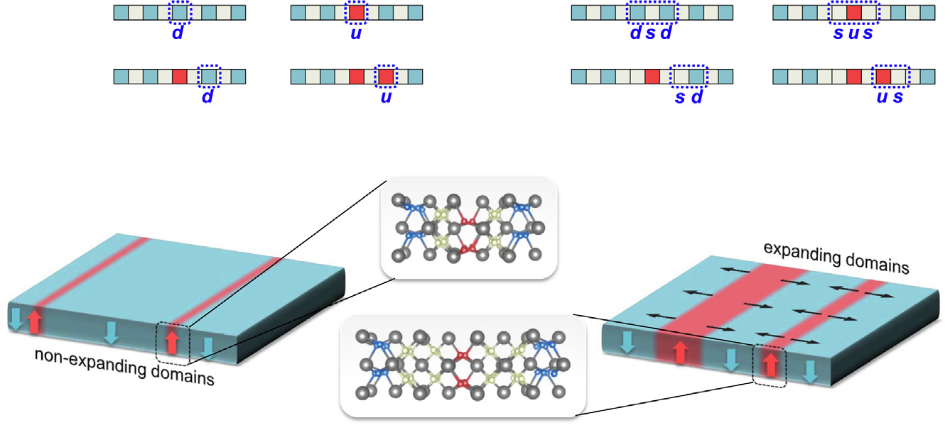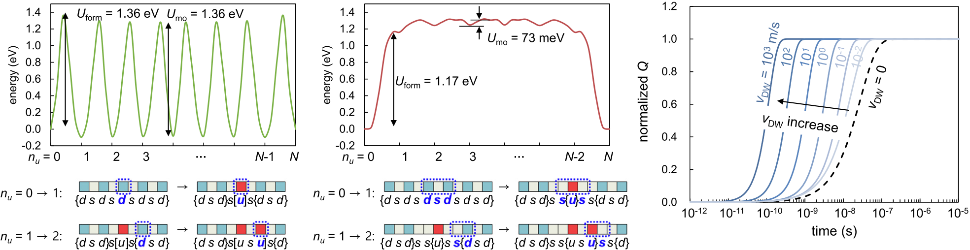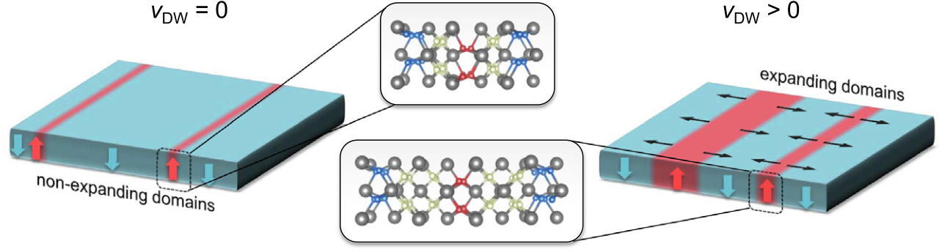

DWs. Here, vc depends on the relative QC between two oppo-site domains, where vc = 0 and 1 for the same and different QC, respectively. In these respects, all DWs considered in this work can be labelled according to (n;vc). The well-known DW [9,15,23,24] is expressed as (1;1) DW. We find that (1;1) DW and the newly revealed (2;0) DW are the two most stable DWs among those considered (n < 5) in this work (Table S1). Note that the transition between (1;1) DW and (2;0) DW requires a global structural change as they belong to different

PbTiO3 (Umo = 1.37 and 1.84 meV/Å2respectively in Refs. [9;31]). The switching process via (2;0) DW exhibits a unique

mechanism involving two consecutive segments of o-HfO2, where their sequence is reversed during the switching procedure, i.e., {���u}ss{dsd���} ? {���usu}ss{d���}. The low Umo in (2;0) DW is attributed to the topology of the DW (vc = 0) having the same QC in the two opposite domains. We find an unusual intermedi-

ate state (Fig. 2d), where its local geometry is reminiscent of the

Pbcn phase (Fig. S3a), the structure observed long ago in Ti doped

|  |  |  |
| --- | --- | --- |
| topological classes. | (b) | HfO2 and ZrO2 [39]. This suggest that the hitherto-overlooked |
| (a) | (d) |
| (c) | (e) |

 



|  |
| --- |
| FIGURE 3 |

Relative total energies during the nucleation and growth from (a) a previous and (b) and our theory show a strikingly different behavior. Schematic illustrations of the reverse domain formation mechanisms are shown below the energy plots. The segments participating in the switching process are highlighted by the blue dashed boxes. (c) Schematic of the two ferroelectric switching scenarios: (a) vDW = 0 and (b) vDW > 0. Calculated (d) normalized polarization Q and (e) logarithmic switching current log(I) as a function of time on the log scale (see Methods). The inset in (e) shows log(ts) as a function of vDW.

11

|  |  |
| --- | --- |
| RESEARCH | Materials TodaydVolume 50 � November 2021 |
| Pbcn structure plays an essential role in polarization switching, which is distinguished from the previously considered interme-diate phases such as Pbca [9] and/or P42/nmc [6]. | energetically more favorable pathway, suggests a rapid expansion of the DWs after the reverse domain formation as Umo � Uform, similar to perovskite-structured ferroelectrics. This explains the |

recent experimental evidence for the nucleation-and-growth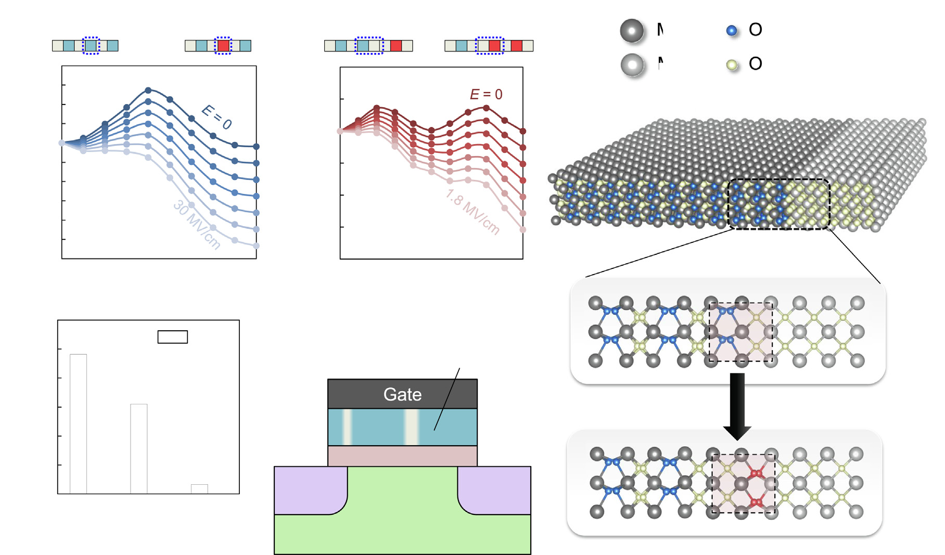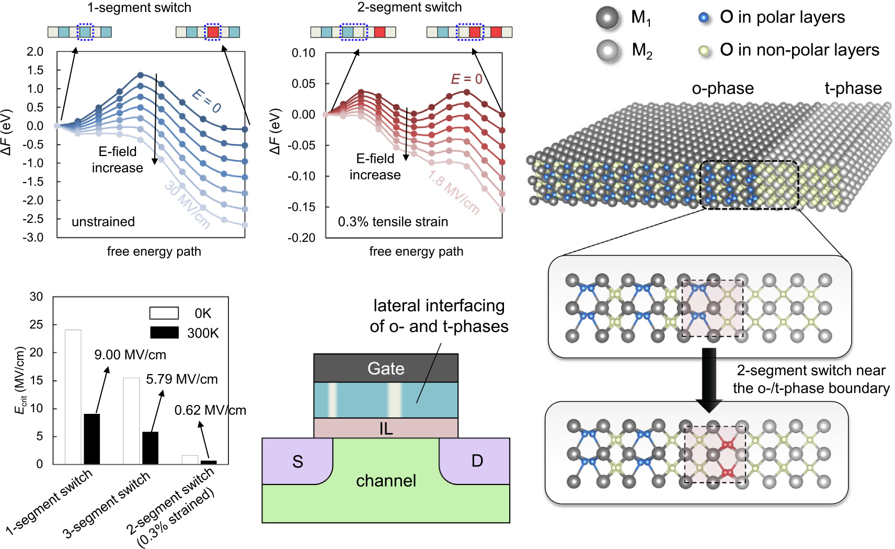

|  |  |
| --- | --- |
| Reverse domain formation and growth  A critical question is whether the new class of DWs can be engi-neered. Here we present two possible scenarios for reverse-domain formation in poled o-HfO2, which is the outcome of the nucleation and forward growth [19]. Fig. 3a illustrates the conventional scenario with a one-segment flip [9,15], with an energy barrier (Uform) of 1.36 eV. In contrast, our new scenario (Fig. 3b) involves a structural transformation of three consecutive segments in o-HfO2, i.e., {���dsdsdsd���} ? {���d}ss{u}ss{d���}, creat-ing (2;0) DWs on both sides of the nucleation site {u}. Intrigu-ingly, the latter case with a seemingly complicated structural transformation has a lower Uform (1.17 eV) than the former case. That is, when a reverse domain forms, creating two (2;0) DWs is preferred over following the conventional model, even when o- | behavior in scaled Zr-doped HfO2 [28] and ultrafast polarization switching HfO2-based ferroelectric devices [25,27].  Such a difference in the switching mechanism, as shown in  Fig. 3c, can further lead to qualitatively different experimental  outcomes. Based on the original Kolmogorov-Avrami-Ishibashi  theory [40] (Methods), we calculated Q(t) and the switching cur-  rent I(t) = dQ(t)/dt for 1-nm-thick o-HfO2 with an area of 10 � 10 lm2(Fig. 3d and 3e). Understandably, the switching speed increases as vDW becomes higher (inset of Fig. 3e). A marked difference between the two scenarios (vDW = 0 and vDW > 0) can be seen in the switching current I(t). When vDW = 0, I(t) can only monotonically decrease as a function of time because I(t) ~ exp(�t/t0), where t0 is the characteristic switching time. By contrast, when vDW > 0, a higher order term |

HfO2 does not have pre-existing (2;0) DWs. After the reverse domain formation, the domain generally expands through side-

ward motion. The prevalent model, however, suggests that the

domain expansion is improbable (DW velocity, vDW, is vanish-ingly small), because Umo is almost equal to the reverse domain

survives in the exponent in Methods Eq. (1), leading to a charac-teristic peak behavior in I(t). For experimental demonstrations, single-crystalline and/or small area o-HfO2 samples would be desirable to avoid the nucleation-limited switching [14] [see also Supplementary material].

|  |  |
| --- | --- |
| formation energy Uform (Fig. 3a). The polar layers in o-HfO2 are effectively decoupled in such scenario [9,32], so that the flipping | Coercive fields |

process does not benefit from being near the DWs. In contrast, our model with (2;0) DW (Fig. 3b), which proceeds through an

To discuss the effect of the switching mechanism on the coercive fields in Hf-based ferroelectrics, we calculate the critical electric

|  |  |  |
| --- | --- | --- |
| (a) | (b) | (e) |
| (c) | (d) |

|  |
| --- |
| FIGURE 4 |

Reduced Ecrit and the proposed device with a gate stack made of fluorite oxides. Field-dependent free energy path for the (a) one-segment and (b) two-segment switching scenarios. The case for the three-segment switching is shown in Fig. S4 in Supplementary Material. (c) Calculated Ecrit for different switching scenarios, where the cases for T = 0 K and 300 K are shown as empty and filled bars, respectively (see Methods). (d) Proposed low-voltage memory device, where the central component is the lateral mixture of o-phase (sky blue) and t-phase (ivory). (e) A sketch of a sharp boundary between the o- and t-phase, which enables a low-barrier reverse domain formation.

12

|  |  |  |  |  |  |  |  |  |
| --- | --- | --- | --- | --- | --- | --- | --- | --- |
| Materials TodaydVolume 50 � November 2021 |  |  |  |  |  |  | RESEARCH | |
|  | thesis | of | highly-textured | [8], | single-phase | [45], | or | single- |
| field, Ecrit, required to overcome the energy barriers for different |
| switching scenarios. Fig. 4a presents the free energy F(E), accord- | crystalline [46,47] HfO2-based ferroelectrics. | | | | |

ing to the semi-classical theory (Methods), during the formation

|  |  |  |
| --- | --- | --- |
| of the reverse domain via the conventional one-segment switch- | Material and methods | RESEARCH: Short Communication |
| ing model. As a comparison, F(E) for the two-segment switching | First-principles calculations of domain walls |
| in +0.3% strained (2;0) DW is also shown in Fig. 4b. While the | First-principles calculations were performed using the general- |
| calculated Ecrit is high (24.1 MV/cm) for the conventional model | ized gradient approximation [48] for the exchange–correlation |
| as expected, our two-segment switching model shows a signifi- | potential and the projector augmented wave potentials [49], as |
| cant reduction of Ecrit (1.67 MV/cm), indicative of a much lower | implemented in the Vienna Ab initio Simulation Package (VASP) |
| coercive field in the presence of (2;0) DW. The inclusion of the |
| code [50]. The wave functions were expanded in plane waves up |
| temperature effect assuming the Curie-Weiss behavior (Methods) | to an energy cut-off of 800 eV, and force tolerance for the struc- |
| results in a further reduction of Ecrit to 0.62 MV/cm at room tem- | ture optimization was 0.01 eV/Å. We used the optimized lattice |
| perature, which is even lower than the measured coercive fields |
| parameters for bulk orthorhombic HfO2, which are a = 5.258 Å, |
| (0.8–2 MV/cm) in Hf-based ferroelectrics [2]. |
| b = 5.047 Å, and c = 5.074 Å, respectively. We used C-centred k |
| On the basis of our findings, we propose a memory device | points generated by 6 � 6 � 6 Monkhorst-Pack meshes, and accordingly adjusted them for the supercell calculations. To con- |
| with a gate stack composed of fluorite oxides (Fig. 4d) that can |
| operate at low voltages. As sketched in Fig. 4e, we design a sharp |  |  |
| sider the domain walls, 1 � 8 � 1 supercell geometries were used, as in previous studies [9,23]. The minimum energy paths and the |
| (010) interface between the orthorhombic (o-; Pca21) and tetrag- |
| onal (t-; P42/nmc) phases [41]. This geometry naturally possesses |
| energy barriers were calculated using the climbing-image nudged |
| a (2;0)-DW-like boundary, thanks to the striking structural simi- |
| elastic band (c-NEB) method [51]. The electrical polarization was |
| larity between the t-phase and the pair of spacers ss in (2;0) DWs |
| calculated using the Berry phase method [52]. The calculated |
| (Fig. 2b and Fig. S3b). In the proposed device, the traditional fer- | remnant polarization for bulk o-HfO2 was 51.5 lC/cm2, which |
| roelectric/dielectric layer is replaced by the laterally heteroge- |
| is in line with previous theoretical [5,23] and experimental [46] |
| neous phases of the fluorite oxides, where small regions of t- |
| reports. |
| phase are interleaved in the o-phase. At the phase boundaries |

(Fig. 4e), the polarization reversal can initiate via the two-segment switching mechanism, avoiding the high Uform of one-or three-segment switching shown in Fig. 3a, b. The required electric field (or voltage) for the polarization switching can there-fore be reduced, suggesting an improved endurance. From a materials perspective, the t-phase is easily synthesized by Zr dop-ing of HfO2 thin films [42].

Kolmogorov–Avrami–Ishibashi model   
The work of Ishibashi and Takagi [40] for describing polarization switching in ferroelectrics is based on the Kolmogorov method [53] and Avrami theory [54,55]. The theory taken together is commonly referred to as the KAI theory. In its original form, the time evolution of the normalized polarization, Q(t), is given as

|  |  |  |  |  |  |
| --- | --- | --- | --- | --- | --- |
| Conclusions and outlook | Q tð Þ ¼ 1 � exp �R� | Z t | Cd rc þ vDW t � s Þ | gdds�; | ð1Þ |

We revealed an unconventional mechanism of ferroelectric polarization switching in orthorhombic HfO2, by establishing a new class of topological DWs. Contrary to the widespread belief, this leads to significantly low intrinsic energy barrier for domain reversal and so allows rapid nucleation and growth of ferroelec-tric domains. Moving forward, our work provides a foundation for exploring topological DWs and phase boundaries in fluorite oxides. In addition to the classification based on n and vc, further classification of the DWs can be made by considering 90� DWs and/or a number of structural variants depending on the relative lattice vector orientations between the domains [23,43], which unlocks the capabilities for polar skyrmion electronics [34,35] based on DWs with vc = 0. In principle, the approach taken for analyzing DWs in o-HfO2 can also be applied to not only the t-phase/o-phase boundary, but other interphase boundaries, such as, between the monoclinic and orthorhombic phases present in polymorphic fluorite oxide films [36,43] [see also Supplemen-tary Material]. This could advance the atomic-scale understand-ing of the morphotropic phase boundaries of Hf1�xZrxO2 [44]. We anticipate that the new class of DWs and fast switching kinetics shown in the present work may be identified in high-quality HfO2 samples. Fortunately, encouraging progress is being made in the development of fabrication techniques for the syn-

where R is the nucleation rate, d is dimensionality, Cd is a factor determined by d, rc is the radius of the nucleation site, and s is the instant nucleation time.

Taking d = 1 according to the anisotropic nature of the o-HfO2 crystal (Fig. 1), Cd becomes Cd ¼ 2w sample width and A (10 � 10 lm2) is the area. Here, rc for the p ffiffiffiffi , where w (1 nm) is the

conventional scenario (Fig. 3a and 3c) and our scenario (Fig. 3b and 3e) are 2.5 Å and 3.75 Å, respectively. There are two unknown parameters: domain wall velocity vDW and nucleation rate R. In general, vDW and R are exponential functions of the applied field E: for example, vDW / exp �aDW=E� and R / exp �an=E�, where aDW and an are activation fields for DW motion and nucleation, respectively. Owing to the lack of reli-able experimental data for vDW and R of o-HfO2, vDW was varied (10�2, 10�1, 100, 101, 102and 103m/s), and R was fixed to 7.2 � 1030s�1m�3, which were considered reasonable values for perovskite oxides according to Ref. [18].

Semi-classical free energy of ferroelectrics   
In the semi-classical theory (see Ref. [56] for example), the free energy of the supercell under consideration, F(E), can be expressed as F(E) = UKS � XPE, where E is the applied electric field, UKS is the total internal energy when E = 0 from first-principles, X

13

|  |  |
| --- | --- |
| RESEARCH | Materials TodaydVolume 50 � November 2021 |
| is the supercell volume, and P is the polarization from the Berry phase calculation [52]. To check the validity of this approach, Ecrit was calculated for homogeneous polarization switching of o-HfO2 [pathway (4)]. The calculated Ecrit was 13.7 MV/cm, which agrees reasonably well with previously calculated values of 13 MV/cm (Ref. [57]) and 15.5 MV/cm (Ref. [37]). | [7] [T. Li et al., Origin of Ferroelectricity in Epitaxial Si-Doped HfO2 Films, ACS Appl.](http://refhub.elsevier.com/S1369-7021(21)00256-X/h0035)  [Mater. Interfaces 11 (2019) 4139–4144](http://refhub.elsevier.com/S1369-7021(21)00256-X/h0035).  [8] [S.S. Cheema et al., Enhanced ferroelectricity in ultrathin f](http://refhub.elsevier.com/S1369-7021(21)00256-X/h0040)i[lms grown directly on](http://refhub.elsevier.com/S1369-7021(21)00256-X/h0040)  [silicon, Nature 580 (2020) 478–482](http://refhub.elsevier.com/S1369-7021(21)00256-X/h0040).  [9] [H.J. Lee et al., Scale-free ferroelectricity induced by f](http://refhub.elsevier.com/S1369-7021(21)00256-X/h0045)l[at phonon bands in HfO2,](http://refhub.elsevier.com/S1369-7021(21)00256-X/h0045)  [Science 369 (2020) 1343–1347](http://refhub.elsevier.com/S1369-7021(21)00256-X/h0045).  [10] [S. Salahuddin, S. Datta, Use of Negative Capacitance to Provide Voltage Amplif](http://refhub.elsevier.com/S1369-7021(21)00256-X/h0050)i[cation for Low Power Nanoscale Devices, Nano Lett. 8 (2008) 405–410](http://refhub.elsevier.com/S1369-7021(21)00256-X/h0050). |

[11] [M. Hoffmann et al., Unveiling the double-well energy landscape in a](http://refhub.elsevier.com/S1369-7021(21)00256-X/h0055)

|  |  |  |  |  |  |  |  |  |  |
| --- | --- | --- | --- | --- | --- | --- | --- | --- | --- |
| Curie–Weiss behavior based on the Landau–Devonshire theory To discuss the temperature (T)-dependent Ecrit in ferroelectrics, we considered the phenomenological theory by Landau and Devonshire (see Ref. [58]). In this theory, the free energy, FLD(E), up to the 4th order term is given as FLD(E) = aP2+ bP4� PE, where a and b are the Landau coefficients. The Curie–Weiss behavior in ferroelectrics is captured by the temperature (T) dependent a, given as a(T) = a0(T � T0), where T0 is the Curie temperature. The T-dependent critical field Ecrit(T) is deduced under equilib- | [ferroelectric layer, Nature 565 (2019) 464–467](http://refhub.elsevier.com/S1369-7021(21)00256-X/h0055).  [12] [J. Íñiguez et al., Ferroelectric negative capacitance, Nat. Rev. Mater. 4 (2019)](http://refhub.elsevier.com/S1369-7021(21)00256-X/h0060)  [243–256](http://refhub.elsevier.com/S1369-7021(21)00256-X/h0060).  [13] [C.H. Ahn, Ferroelectricity at the nanoscale: local polarization in oxide thin f](http://refhub.elsevier.com/S1369-7021(21)00256-X/h0065)i[lms](http://refhub.elsevier.com/S1369-7021(21)00256-X/h0065)  [and heterostructures, Science 303 (2004) 488–491](http://refhub.elsevier.com/S1369-7021(21)00256-X/h0065).  [14] [P. Buragohain et al., Nanoscopic studies of domain structure dynamics in](http://refhub.elsevier.com/S1369-7021(21)00256-X/h0070)  [ferroelectric La:HfO2 capacitors, Appl. Phys. Lett. 112 (2018) 222901](http://refhub.elsevier.com/S1369-7021(21)00256-X/h0070).  [15] [K. Lee et al., Stable Subloop Behavior in Ferroelectric Si-Doped HfO2, ACS Appl.](http://refhub.elsevier.com/S1369-7021(21)00256-X/h0075)  [Mater. Interfaces 11 (2019) 38929–38936](http://refhub.elsevier.com/S1369-7021(21)00256-X/h0075). | | | | | | | | |
| [16] [L.W.](http://refhub.elsevier.com/S1369-7021(21)00256-X/h0080) | [Martin,](http://refhub.elsevier.com/S1369-7021(21)00256-X/h0080) | [A.M.](http://refhub.elsevier.com/S1369-7021(21)00256-X/h0080) | [Rappe,](http://refhub.elsevier.com/S1369-7021(21)00256-X/h0080) | [Thin-f](http://refhub.elsevier.com/S1369-7021(21)00256-X/h0080)i[lm](http://refhub.elsevier.com/S1369-7021(21)00256-X/h0080) | [ferroelectric](http://refhub.elsevier.com/S1369-7021(21)00256-X/h0080) | [materials](http://refhub.elsevier.com/S1369-7021(21)00256-X/h0080) | [and](http://refhub.elsevier.com/S1369-7021(21)00256-X/h0080) | [their](http://refhub.elsevier.com/S1369-7021(21)00256-X/h0080) |
| [applications, Nat. Rev. Mater. 2 (2017) 16087](http://refhub.elsevier.com/S1369-7021(21)00256-X/h0080). | | | | | | | | |
| rium condition, which can be expressed as Ecrit(T) = {(T0 � T)/T0-}3/2� Ecrit(T = 0 K). Using the experimentally measured  T0 = 350 �C (Ref. [59]), Ecrit(300 K) = 0.373 � Ecrit(T = 0 K) was  obtained at room temperature. | [17] [W.J. Merz, Domain Formation and Domain Wall Motions in Ferroelectric](http://refhub.elsevier.com/S1369-7021(21)00256-X/h0085)  [BaTiO3 Single Crystals, Phys. Rev. 95 (1954) 690–698](http://refhub.elsevier.com/S1369-7021(21)00256-X/h0085).  [18] [Y.H. Shin et al., Nucleation and growth mechanism of ferroelectric domain-wall](http://refhub.elsevier.com/S1369-7021(21)00256-X/h0090)  [motion, Nature 449 (2007) 881–884](http://refhub.elsevier.com/S1369-7021(21)00256-X/h0090).  [19] [D. Meier, J. Seidel, M. Gregg, R. Ramesh, Domain Walls, Oxford University](http://refhub.elsevier.com/S1369-7021(21)00256-X/h0095)  [Press, 2020](http://refhub.elsevier.com/S1369-7021(21)00256-X/h0095). | | | | | | | | |

[20] [M. Hoffmann et al., What’s next for negative capacitance electronics?, Nat](http://refhub.elsevier.com/S1369-7021(21)00256-X/h0100)

CRediT authorship contribution statement   
Duk-Hyun Choe: Conceptualization, Methodology, Software, Validation, Formal analysis, Investigation, Writing – original draft, Writing - review & editing, Visualization. Sunghyun Kim: Validation, Writing - review & editing. Taehwan Moon: Validation. Sanghyun Jo: Validation. Hagyoul Bae: Validation. Seung-Geol Nam: Validation. Yun Seong Lee: Validation. Jinseong Heo: Conceptualization, Validation, Writing - review & editing, Supervision, Project administration.

Declaration of Competing Interest   
 The authors declare that they have no known competing financial interests or personal relationships that could have appeared to influence the work reported in this paper.

Acknowledgements   
 We thank Hyoung Sub Kim, Eunha Lee, and Hyangsook Lee for their insightful comments on the experimental identifica-tions of DWs.

Appendix A. Supplementary data   
Supplementary data to this article can be found online at <https://doi.org/10.1016/j.mattod.2021.07.022>.

[Electron. 3 (2020) 504–506](http://refhub.elsevier.com/S1369-7021(21)00256-X/h0100).

[21] [C.T. Nelson et al., Domain Dynamics During Ferroelectric Switching, Science](http://refhub.elsevier.com/S1369-7021(21)00256-X/h0105)  [334 (2011) 968–971](http://refhub.elsevier.com/S1369-7021(21)00256-X/h0105).

[22] [M.H. Park et al., The effects of crystallographic orientation and strain of thin](http://refhub.elsevier.com/S1369-7021(21)00256-X/h0110)  [Hf0.5Zr0.5O2 f](http://refhub.elsevier.com/S1369-7021(21)00256-X/h0110)i[lm on its ferroelectricity, Appl. Phys. Lett. 104 (2014) 072901](http://refhub.elsevier.com/S1369-7021(21)00256-X/h0110). [23] [W. Ding et al., The atomic-scale domain wall structure and motion in HfO2-](http://refhub.elsevier.com/S1369-7021(21)00256-X/h0115) [based ferroelectrics: A f](http://refhub.elsevier.com/S1369-7021(21)00256-X/h0115)i[rst-principle study, Acta Mater. 196 (2020) 556–564](http://refhub.elsevier.com/S1369-7021(21)00256-X/h0115). [24] [Y.-W. Chen, S.-T. Fan, C.W. Liu, Energy preference of uniform polarization](http://refhub.elsevier.com/S1369-7021(21)00256-X/h0120)  [switching for HfO2 by f](http://refhub.elsevier.com/S1369-7021(21)00256-X/h0120)i[rst-principle study, J. Phys. D. Appl. Phys. 54 (2020)](http://refhub.elsevier.com/S1369-7021(21)00256-X/h0120)  [085304](http://refhub.elsevier.com/S1369-7021(21)00256-X/h0120).

[25] [X. Lyu, M. Si, P.R. Shrestha, J.P. Campbell, K.P. Cheung, P.D. Ye, Record Fast Polarization Switching Observed in Ferroelectric Hafnium Oxide Crossbar Arrays, 2020 IEEE Silicon Nanoelectron. Work. (SNW) (2020) 7–8](http://refhub.elsevier.com/S1369-7021(21)00256-X/h0125).

[26] [M. Si et al., Ultrafast measurements of polarization switching dynamics on ferroelectric and anti-ferroelectric hafnium zirconium oxide, Appl. Phys. Lett. 115 (2019) 072107](http://refhub.elsevier.com/S1369-7021(21)00256-X/h0130).

[27] [H. Bae, S.G. Nam, T. Moon, Y. Lee, S. Jo, D.H. Choe, S. Kim, K.-H. Lee, J. Heo, Sub-ns Polarization Switching in 25nm FE FinFET toward Post CPU and Spatial-Energetic Mapping of Traps for Enhanced Endurance, 2020 IEEE International Electron Devices Meeting (IEDM) (2020) 31.3](http://refhub.elsevier.com/S1369-7021(21)00256-X/h0135).

[28] [K. Lee et al., Effects of Process-Induced Defects on Polarization Switching in Ferroelectric Tunneling Junction Memory, IEEE Electron. Device Lett. 42 (2021) 323–326](http://refhub.elsevier.com/S1369-7021(21)00256-X/h0140).

[29] [H.W. Park et al., Modeling of Negative Capacitance in Ferroelectric Thin Films,](http://refhub.elsevier.com/S1369-7021(21)00256-X/h0145)  [Adv. Mater. (2019) 1805266](http://refhub.elsevier.com/S1369-7021(21)00256-X/h0145).

[30] [A.K. Saha, S.K. Gupta, Multi-Domain Negative Capacitance Effects in Metal-Ferroelectric-Insulator-Semiconductor/Metal Stacks: A Phase-f](http://refhub.elsevier.com/S1369-7021(21)00256-X/h0150)i[eld Simulation Based Study, Sci. Rep. 10 (2020) 10207](http://refhub.elsevier.com/S1369-7021(21)00256-X/h0150).

[31] [X.Y. Li et al., Domain Wall Motion in Perovskite Ferroelectrics Studied by the](http://refhub.elsevier.com/S1369-7021(21)00256-X/h0155)  [Nudged Elastic Band Method, J. Phys. Chem. C 122 (2018) 3091–3100](http://refhub.elsevier.com/S1369-7021(21)00256-X/h0155).

[32] [B. Noheda, J. Íñiguez, A key piece of the ferroelectric hafnia puzzle, Science 369](http://refhub.elsevier.com/S1369-7021(21)00256-X/h0160)  [(2020) 1300–1301](http://refhub.elsevier.com/S1369-7021(21)00256-X/h0160).

References [33] [W. Chung, M. Si, P.R. Shrestha, J.P. Campbell, K.P. Cheung, P.D. Ye, First Direct](http://refhub.elsevier.com/S1369-7021(21)00256-X/h0165)

[1] [T.S. Böscke et al., Ferroelectricity in hafnium oxide thin f](http://refhub.elsevier.com/S1369-7021(21)00256-X/h0005)i[lms, Appl. Phys. Lett.](http://refhub.elsevier.com/S1369-7021(21)00256-X/h0005)  [Experimental Studies of Hf0.5Zr0.5O2 Ferroelectric Polarization Switching Down](http://refhub.elsevier.com/S1369-7021(21)00256-X/h0165)

[99 (2011) 102903](http://refhub.elsevier.com/S1369-7021(21)00256-X/h0005). [to 100-picosecond in Sub-60mV/dec Germanium Ferroelectric Nanowire FETs,](http://refhub.elsevier.com/S1369-7021(21)00256-X/h0165)

[2] [T. Mikolajick et al., Ferroelectric hafnium oxide for ferroelectric random-access](http://refhub.elsevier.com/S1369-7021(21)00256-X/h0010)  [2018 IEEE Symposium on VLSI Technology (2018) 89–90](http://refhub.elsevier.com/S1369-7021(21)00256-X/h0165).

[memories and ferroelectric f](http://refhub.elsevier.com/S1369-7021(21)00256-X/h0010)i[eld-effect transistors, MRS Bull. 43 (2018) 340–346](http://refhub.elsevier.com/S1369-7021(21)00256-X/h0010). [34] [S. Das et al., Observation of room-temperature polar skyrmions, Nature 568](http://refhub.elsevier.com/S1369-7021(21)00256-X/h0170)

[3] [U. Schroeder, C.S. Hwang, H. Funakubo, Ferroelectricity in Doped Hafnium](http://refhub.elsevier.com/S1369-7021(21)00256-X/h0015)  [(2019) 368–372](http://refhub.elsevier.com/S1369-7021(21)00256-X/h0170).

[Oxide: Materials, Properties and Devices, Elsevier, 2019](http://refhub.elsevier.com/S1369-7021(21)00256-X/h0015).

[4] [A.I. Khan, A. Keshavarzi, S. Datta, The future of ferroelectric f](http://refhub.elsevier.com/S1369-7021(21)00256-X/h0020)i[eld-effect](http://refhub.elsevier.com/S1369-7021(21)00256-X/h0020)  [transistor technology, Nat. Electron. 3 (2020) 588–597](http://refhub.elsevier.com/S1369-7021(21)00256-X/h0020).

[5] [S. Clima et al., Identif](http://refhub.elsevier.com/S1369-7021(21)00256-X/h0025)i[cation of the ferroelectric switching process and dopant-dependent switching properties in orthorhombic HfO2: A f](http://refhub.elsevier.com/S1369-7021(21)00256-X/h0025)i[rst principles insight, Appl. Phys. Lett. 104 (2014) 092906](http://refhub.elsevier.com/S1369-7021(21)00256-X/h0025).

[6] [T.D. Huan et al., Pathways towards ferroelectricity in hafnia, Phys. Rev. B 90](http://refhub.elsevier.com/S1369-7021(21)00256-X/h0030)  [(2014) 064111](http://refhub.elsevier.com/S1369-7021(21)00256-X/h0030).

[35] [S. Das et al., Local negative permittivity and topological phase transition in](http://refhub.elsevier.com/S1369-7021(21)00256-X/h0175)  [polar skyrmions, Nat. Mater. 20 (2021) 194–201](http://refhub.elsevier.com/S1369-7021(21)00256-X/h0175).

[36] [E.D. Grimley et al., Atomic Structure of Domain and Interphase Boundaries in](http://refhub.elsevier.com/S1369-7021(21)00256-X/h0180)  [Ferroelectric HfO2, Adv. Mater. Interfaces 5 (2018) 1701258](http://refhub.elsevier.com/S1369-7021(21)00256-X/h0180).

[37] [T. Maeda, B. Magyari-Kope, Y. Nishi, Identifying Ferroelectric Switching Pathways in HfO2: First Principles Calculations under Electric Fields, 2017 IEEE International Memory Workshop (IMW) (2017) 1–4](http://refhub.elsevier.com/S1369-7021(21)00256-X/h0185).

14

|  |  |  |
| --- | --- | --- |
| Materials TodaydVolume 50 � November 2021 | RESEARCH |  |
|  | [48] [J.P. Perdew, K. Burke, M. Ernzerhof, Generalized Gradient Approximation Made](http://refhub.elsevier.com/S1369-7021(21)00256-X/h0240) | |  | | --- | | RESEARCH: Short Communication | |
| [38] [S. Clima, B.J. O’Sullivan, N. Ronchi, M.G. Bardon, K. Banerjee, G. Van den](http://refhub.elsevier.com/S1369-7021(21)00256-X/h0190) |
| [Bosch, G. Pourtois, J. Van Houdt, Ferroelectric Switching in FEFET: Physics of](http://refhub.elsevier.com/S1369-7021(21)00256-X/h0190) | [Simple, Phys. Rev. Lett. 77 (1996) 3865–3868](http://refhub.elsevier.com/S1369-7021(21)00256-X/h0240). |
| [the Atomic Mechanism and Switching Dynamics in HfZrOx, HfO2 with Oxygen](http://refhub.elsevier.com/S1369-7021(21)00256-X/h0190) | [49] [P.E. Blöchl, Projector augmented-wave method, Phys. Rev. B 50 (1994) 17953–](http://refhub.elsevier.com/S1369-7021(21)00256-X/h0245) |
| [Vacancies and Si dopants, 2020 IEEE International Electron Devices Meeting](http://refhub.elsevier.com/S1369-7021(21)00256-X/h0190) | [17979](http://refhub.elsevier.com/S1369-7021(21)00256-X/h0245). |
| [(IEDM) (2020) 4.2](http://refhub.elsevier.com/S1369-7021(21)00256-X/h0190). | [50] [G. Kresse, J. Furthmüller, Eff](http://refhub.elsevier.com/S1369-7021(21)00256-X/h0250)i[cient iterative schemes for ab initio total-energy](http://refhub.elsevier.com/S1369-7021(21)00256-X/h0250) |
| [39] [M.A. Krebs, R.A. Condrate, A Raman spectral characterization of various](http://refhub.elsevier.com/S1369-7021(21)00256-X/h0195) | [calculations using a plane-wave basis set, Phys. Rev. B 54 (1996) 11169–11186](http://refhub.elsevier.com/S1369-7021(21)00256-X/h0250). |
| [crystalline mixtures in the ZrO2-TiO2 and HfO2-TiO2 systems, J. Mater. Sci.](http://refhub.elsevier.com/S1369-7021(21)00256-X/h0195) | [51] [G. Henkelman, B.P. Uberuaga, H. Jónsson, A climbing image nudged elastic](http://refhub.elsevier.com/S1369-7021(21)00256-X/h0255) |
| [Lett. 7 (1988) 1327–1330](http://refhub.elsevier.com/S1369-7021(21)00256-X/h0195). | [band method for f](http://refhub.elsevier.com/S1369-7021(21)00256-X/h0255)i[nding saddle points and minimum energy paths, J. Chem.](http://refhub.elsevier.com/S1369-7021(21)00256-X/h0255) |
| [40] [Y. Ishibashi, Y. Takagi, Note on ferroelectric domain switching, J. Phys. Soc.](http://refhub.elsevier.com/S1369-7021(21)00256-X/h0200) | [Phys. 113 (2000) 9901–9904](http://refhub.elsevier.com/S1369-7021(21)00256-X/h0255). |
| [Japan 31 (1971) 506–510](http://refhub.elsevier.com/S1369-7021(21)00256-X/h0200). | [52] [R.D. King-Smith, D. Vanderbilt, Theory of polarization of crystalline solids,](http://refhub.elsevier.com/S1369-7021(21)00256-X/h0260) |
| [41] [K. Chae et al., Stability of ferroelectric and antiferroelectric hafnium–zirconium](http://refhub.elsevier.com/S1369-7021(21)00256-X/h0205) | [Phys. Rev. B 47 (1993) 1651–1654](http://refhub.elsevier.com/S1369-7021(21)00256-X/h0260). |
| [oxide thin f](http://refhub.elsevier.com/S1369-7021(21)00256-X/h0205)i[lms, J. Appl. Phys. 128 (2020) 054101](http://refhub.elsevier.com/S1369-7021(21)00256-X/h0205). | [53] [A.N. Kolmogorov, On the statistical theory of the crystallization of metals, Bull.](http://refhub.elsevier.com/S1369-7021(21)00256-X/h0265) |
| [42] [J. Müller et al., Ferroelectricity in Simple Binary ZrO2 and HfO2, Nano Lett. 12](http://refhub.elsevier.com/S1369-7021(21)00256-X/h0210) | [Acad. Sci. USSR Math. Ser 3 (1937) 355](http://refhub.elsevier.com/S1369-7021(21)00256-X/h0265). |
| [(2012) 4318–4323](http://refhub.elsevier.com/S1369-7021(21)00256-X/h0210). | [54] [M. Avrami, Kinetics of Phase Change. I General Theory, J. Chem. Phys. 7 (1939)](http://refhub.elsevier.com/S1369-7021(21)00256-X/h0270) |
| [43] [T. Kiguchi et al., Domain orientation relationship of orthorhombic and](http://refhub.elsevier.com/S1369-7021(21)00256-X/h0215) | [1103–1112](http://refhub.elsevier.com/S1369-7021(21)00256-X/h0270). |
| [coexisting monoclinic phases of YO1.5-doped HfO2 epitaxial thin f](http://refhub.elsevier.com/S1369-7021(21)00256-X/h0215)i[lms, Jpn. J.](http://refhub.elsevier.com/S1369-7021(21)00256-X/h0215) | [55] [M. Avrami, Kinetics of Phase Change. II Transformation-Time Relations for](http://refhub.elsevier.com/S1369-7021(21)00256-X/h0275) |
| [Appl. Phys. 57 (2018) 11UF16](http://refhub.elsevier.com/S1369-7021(21)00256-X/h0215). | [Random Distribution of Nuclei, J. Chem. Phys. 8 (1940) 212–224](http://refhub.elsevier.com/S1369-7021(21)00256-X/h0275). |
| [44] [M.H. Park et al., Morphotropic Phase Boundary of Hf1–xZrxO2 Thin Films for](http://refhub.elsevier.com/S1369-7021(21)00256-X/h0220) | [56] [A.-M. El-Sayed et al., Effect of electric f](http://refhub.elsevier.com/S1369-7021(21)00256-X/h0280)i[eld on migration of defects in oxides:](http://refhub.elsevier.com/S1369-7021(21)00256-X/h0280) |
| [Dynamic Random Access Memories, ACS Appl. Mater. Interfaces 10 (2018)](http://refhub.elsevier.com/S1369-7021(21)00256-X/h0220) | [Vacancies and interstitials in bulk MgO, Phys. Rev. B 98 (2018) 064102](http://refhub.elsevier.com/S1369-7021(21)00256-X/h0280). |
| [42666–42673](http://refhub.elsevier.com/S1369-7021(21)00256-X/h0220). | [57] [Y. Qi, K.M. Rabe, Phase competition in HfO2 with applied electric f](http://refhub.elsevier.com/S1369-7021(21)00256-X/h0285)i[eld from f](http://refhub.elsevier.com/S1369-7021(21)00256-X/h0285)i[rst](http://refhub.elsevier.com/S1369-7021(21)00256-X/h0285) |

[45] [H.Y. Yoong et al., Epitaxial Ferroelectric Hf0.5Zr0.5O2 Thin Films and Their Implementations in Memristors for Brain-Inspired Computing, Adv. Funct. Mater. 28 (2018) 1806037](http://refhub.elsevier.com/S1369-7021(21)00256-X/h0225).

[46] [T. Shimizu et al., The demonstration of signif](http://refhub.elsevier.com/S1369-7021(21)00256-X/h0230)i[cant ferroelectricity in epitaxial Y-](http://refhub.elsevier.com/S1369-7021(21)00256-X/h0230) [doped HfO2 f](http://refhub.elsevier.com/S1369-7021(21)00256-X/h0230)i[lm, Sci. Rep. 6 (2016) 32931](http://refhub.elsevier.com/S1369-7021(21)00256-X/h0230).

[principles, Phys. Rev. B 102 (2020) 214108](http://refhub.elsevier.com/S1369-7021(21)00256-X/h0285).

[58] [P. Chandra, P.B. Littlewood, A Landau Primer for Ferroelectrics, Physics of](http://refhub.elsevier.com/S1369-7021(21)00256-X/h0290)  [Ferroelectrics, Springer Berlin Heidelberg, 2007, pp. 69–116](http://refhub.elsevier.com/S1369-7021(21)00256-X/h0290).

[59] [T. Mimura et al., Thickness- and orientation- dependences of Curie temperature in ferroelectric epitaxial Y doped HfO2 f](http://refhub.elsevier.com/S1369-7021(21)00256-X/h0295)i[lms, Jpn. J. Appl. Phys. 59 (2020)](http://refhub.elsevier.com/S1369-7021(21)00256-X/h0295)

[47] [X. Xu et al., Kinetically stabilized ferroelectricity in bulk single-crystalline HfO2:](http://refhub.elsevier.com/S1369-7021(21)00256-X/h0235)  [SGGB04](http://refhub.elsevier.com/S1369-7021(21)00256-X/h0295).

[Y, Nat. Mater. 20 (2021) 826–832](http://refhub.elsevier.com/S1369-7021(21)00256-X/h0235).

15